August 2014 ESIP Journal

Student built, Fishermen deployed, Satellite tracked Drifters
Educators and their students help scientists better understand transport pathways by providing surface current information to modelers with drifters. These drifters provide students with a hands-on introduction to physical oceanography by engaging them in the entire process from building, to deploying, to following their tracks online. Why drifters? Drifters track currents which are important for model validation, search and rescue, red tide and harmful algae blooms, oil spills, recovery, larval distribution, safe maritime operations, pollution, and storm accuracy and weather predictions. Over 50 different academic institutions ranging from preschool to graduate level oceanography programs have been involved with construction and deployment of these drifters. Lesson plans ranging from simple concepts of latitude and longitude to complex studies of dispersion have been developed.
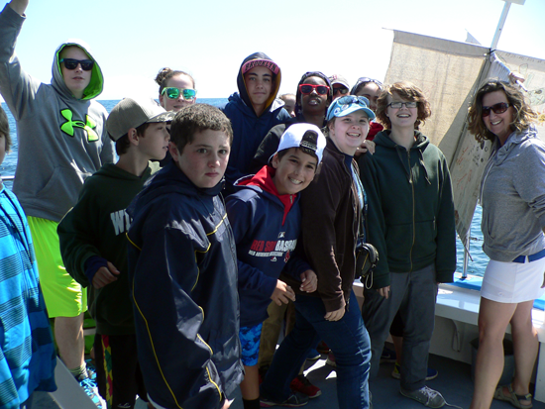
Jim Manning from the NOAA Northeast Fisheries Science Center, has been building drifters for over a decade. These drifters are constructed with low-cost, locally available, eco-friendly materials. They are named after the student or researcher who first designed or inspired its prototype. While the size and shape remain consistent, past models have evolved from the original PVC-framed “Rachel”, to the bamboo-framed “Cassie”, and many others. The current design is the “Irina” which is constructed with a set of cotton sails supported by aluminum spars which are mounted orthogonally around a 6′ length of 1” square aluminum pipe. A set of two fishermen’s net buoys are lashed around the neck of the drifter for flotation. The GPS transmitter is mounted on the top. Contact information and art work can be easily posted along the mast, on the top of the transmitter, or printed on the sails. The entire unit weighs approximately 20 lbs and floats to minimize windage. These units can be built by students at nearly any level with some adult supervision and instructions as posted at studentdrifters.org.
Data is delivered in a variety of formats and displays. It contributes to the US Integrated Ocean Observing System and used by numerical ocean modelers to validate their simulations. In the Northeast, data contributes to the Northeastern Regional Association of Coastal Ocean Observing Systems, NERACOOS. Data is accessible online and can be followed in real time in the classroom.
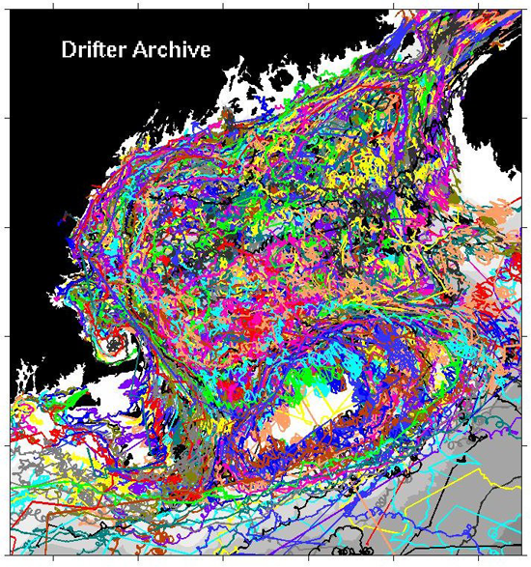

Contact Information
Jim Manning Technical Support: james.manning@noaa.gov
Erin Pelletier Finance/Billing: erin@gomlf.org
Abigail Smith Education Coordinator: abigailalice.smith@gmail.com
Cassie Stymiest NERACOOS Liaison: cassie@neracoos.org
Drifter construction site, lesson plans: www.studentdrifters.org
Drifter tracking and additional info: www.nefsc.noaa.gov/drifter
Individual school pages:www.neracoos.org/drifters

